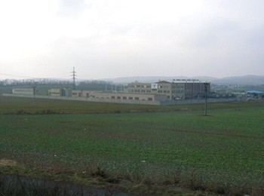
RWE Transgas

RWE Transgas is a part of a international energetic RWE group, and governs its activity in Czech Republic.

Location:

The Underground gas container is located 6 km northly from Mikulov, under the east foothill of Pavlov Hills, in the areas of Dolni Dunajovice, Horní Věstonice and Březí.The gas container is the largest in Czech republic.

History:

Within the frame of regional seismic investigation of Karpatské frontal excavation, was found a hopeful structure for acumulation of hydrocarbons, near the village Dolní Dunajvice,by the Věstonickém rille.Right within the first bore was in the year 1973 discovered the apperance of a very high amount of earthgas.Within the prime mining of earthgas was deciced, that after mining over 50% of the supply,there will be constructed a underground container of gas on the structure.

Geologie:

The trench rock of the gas bearing, put in depth of 1500 m under the ground, is formed from chloritic-gaukonitic sandstone, developed in seven hydrodynamic united levels, partly separated with irregual layers of claystone, so it produces one hydrodynamic complex.The top of the structure produces the Věstonic rille, with the throw cca. 150 m in the same level as the mezozoic calcites, on whose are mounted the eggenburg clastic.Overburden of the gas-bearing horizont, is made from calcit claystones, whose upper border goes through a boundary line of egegnburg – karpat. In the south part of the structure was in the karpat sediments found a small acumulation of gas in the depth of 600 m.

Overground part:

UCG has a technology for impress, and for mining the gas either, whereas a part of the technology for impress and mining is joint. A part of UCG are four collecting centers. UCG is connected on gaslines of the shipping system Uheřice-Dolní Dunajovice.

